University of Maryland
CMSC 421: Introduction to Artificial Intelligence

Project 1: Informed Search Algorithms for Travelling Salesman Problem

Part 3: Hill Climbing, Simulated Annealing, Genetic Algorithms

Jaehyun Kwak
2025.09.25

Table of Contents
- Algorithm Setup
- Experiment Setup
- Results and Discussion
- Questions to Consider

- Algorithm Setup
In the implementation of the Traveling Salesman Problem, a solution is represented as a permutation of the cities, with the cost defined as the sum of edge weights along the tour, including the return to the start. For local search methods such as hill climbing and simulated annealing, a neighbor solution is defined by a 2-swap move, in which two positions in the permutation are exchanged. This neighborhood structure allows incremental evaluation of the change in tour cost and serves as the foundation of both deterministic and stochastic search. For the genetic algorithm, new candidate tours are generated by crossover and mutation; the mutation operator is also a 2-swap, which introduces diversity in the population.

- Hill Climbing
The hill climbing algorithm with random restarts begins from randomly generated permutations and repeatedly applies improving 2-swaps until no further improvements are possible, reaching a local optimum., Because the algorithm is greedy, it may easily become trapped; therefore, multiple restarts from different initial tours are performed, and the best result across restarts is taken as the final solution.
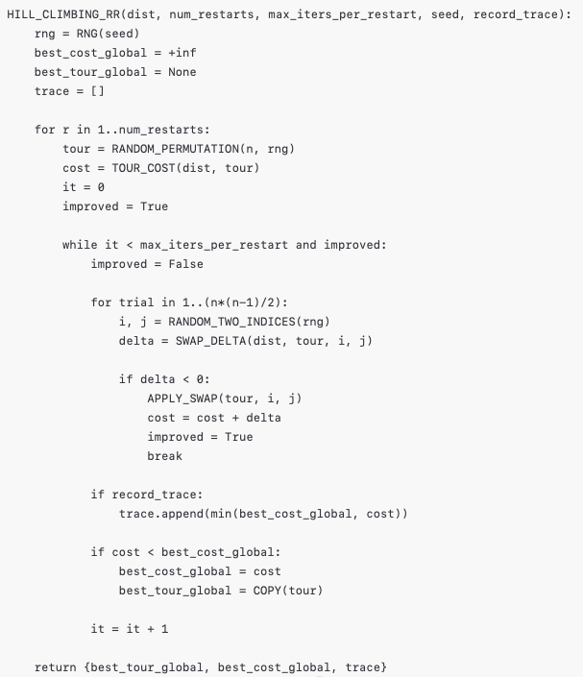
<Algorithm 1: Hill Climbing>

- Simulated Annealing
The simulated Annealing algorithm uses the same 2-swap neighborhood but augments it with a probabilistic acceptance rule. At each step, an improving move is always accepted, while a worsening move may be accepted with probability $\exp\left(-Δ/T\right)$, where $T$ is the current temperature. The temperature decreases geometrically by a factor $α$ at each iteration. This mechanism allows the algorithm to escape local optima early in the run and gradually focus on exploitation as the temperature cools.

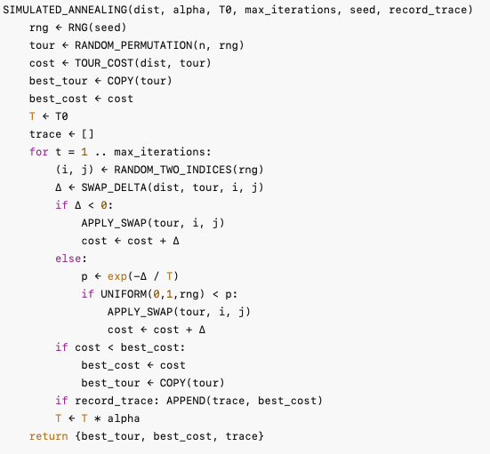
<Algorithm 2: Simulated Annealing>

- Genetic Algorithms
The genetic algorithm maintains a population of candidate tours and evolves them over generations. Parents are selected by tournament selection; offspring are produced by order-preserving crossover, ensuring that city permutations remain valid; and mutation is applied with a given probability to swap two positions in a tour. Elitism is used to guarantee that the best individuals survivie each generation.

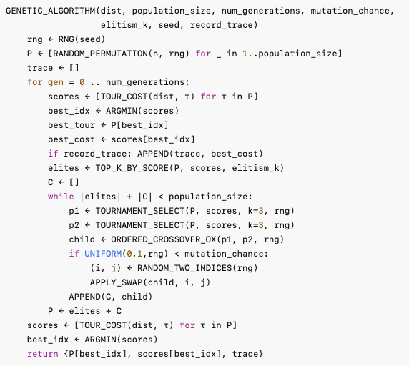
<Algorithm 3: Simulated Annealing>

- Experiment Setup
The same adjacency matrices for size $n ∈\{5, 10, 15, 20, 25, 30\}$ were used. Each algorithm was executed on all instances, and performance was measured by medians of wall-clock time, CPU time, and tour cost, respectively, consistent with the metrics from part 1 and 2.
The following algorithms are evaluated via <main.py> functions: hill_climbing, simulated_annealing, genetic_algorithm, and the A* baseline (a_star). For every run best tour cost, wall-clock time, and cpu time were recorded.
Hyperparameters were tuned to minimize the overall median tour cost, computed as the median across instances for each $n$ and then the median across all $n$. For hill climbing, the number of restarts was sweeped over [5, 10, 20, 40, 80] with 5,000 iterations per restart, selecting the restart count that yields the lowest overall median. For simulated Annealing, we use geometric cooling T←αT with $α∈0.990,0.993,0.995,0.996,0.997$, fix the initial temperature to 100.0 and the maximum iterations to 5,000, and pick the best $α$. For the genetic algorithm, we perform a two-stage sweep: first fix population size to 20 (the midpoint of [10, 15, 20, 25, 30]) and sweep mutation rates [0.02, 0.05, 0.10, 0.15, 0.20] to pick the best; then fix that mutation rate and sweep population sizes [10, 15, 20, 25, 30]. GA runs for 50 generations throughout.

- Result and Discussion - Hyperparameters
Figure 1 shows that overall median tour cost as the number of hill-climbing restarts increases. Cost edges up from 5 to 10, then drops sharply at 20, and continues to decline at 40 and 80. The biggest improvement comes between 10 and 20 with roughly a ten percent reduction by eye. Gains from 20 to 40 are small, and from 40 to 80 the curve flattens further. Among the tested values the lowest overall median occurs at 80 restarts.
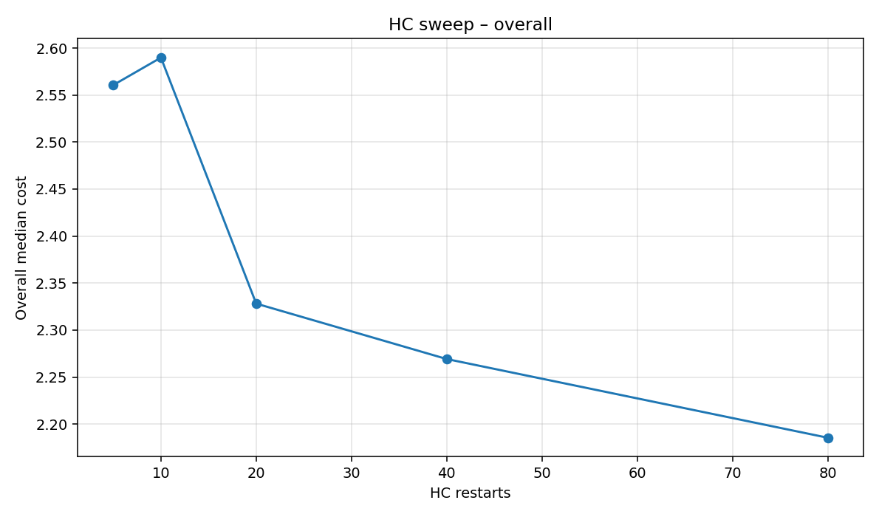
<Figure 1: Hill Climbing Restarts Sweep
Figure 2 reports the overall median tour cost from the simulated annealing sweep over different cooling rates α={0.990,0.993,0.995,0.996,0.997}, with the initial temperature fixed at 100.0 and the iteration cap set to 5000. It is shown that low values of $α$ such as 0.990 or 0.993 cool the system too quickly, causing premature freezing and entrapment in poor local minima, while high values such as 0.996 or 0.997 cool too slowly and spend much of the run wandering without sufficient refinement. The best performance appears at $α= 0.995$, which provides a balance. It keeps the temperature high long enough to escape shallow minima but cools rapidly enough to allow convergence toward better tours. This outcome reflects the interaction between the fixed initial temperature, the geometric schedule, and the rugged landscape defined by the 2-swap neighborhood.

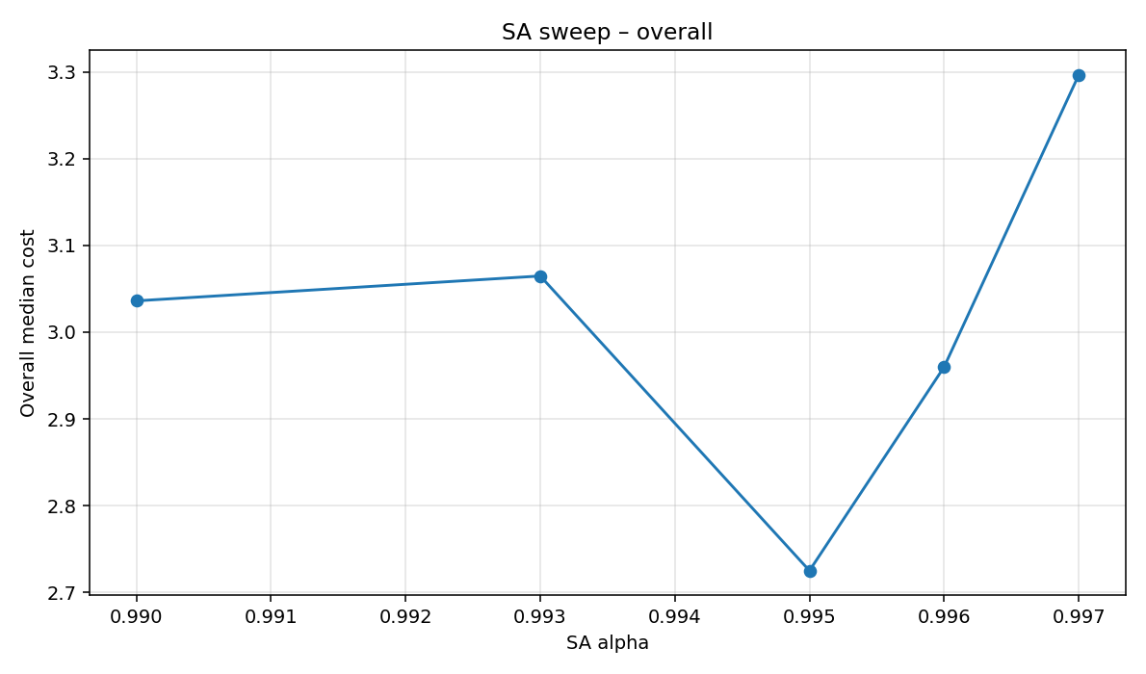
<Figure 2: Simulated Annealing $α$ Sweep>
Figure 3 shows the overall median tour cost from the genetic algorithm sweep over mutation rates in the grid [0.02, 0.05, 0.10, 0.15, 0.20], with population size fixed at 20 and 50 generations as specified in the code. Performance is unstable at the extremes: a low mutation rate of 0.02 yields moderate costs but risks premature convergence, while 0.05 produces the worst result of the sweep, suggesting insufficient diversity and entrapment in poor solutions. Increasing the mutation rate improves results, with the lowest overall median at 0.15, where diversity is high enough to escape local optima while still allowing convergence. At 0.20, the cost rises again, indicating that excessive randomness disrupts useful building blocks. This pattern reflects the code’s use of two-swap mutation within a relatively small population, making a mid-range mutation probability the most effective balance.
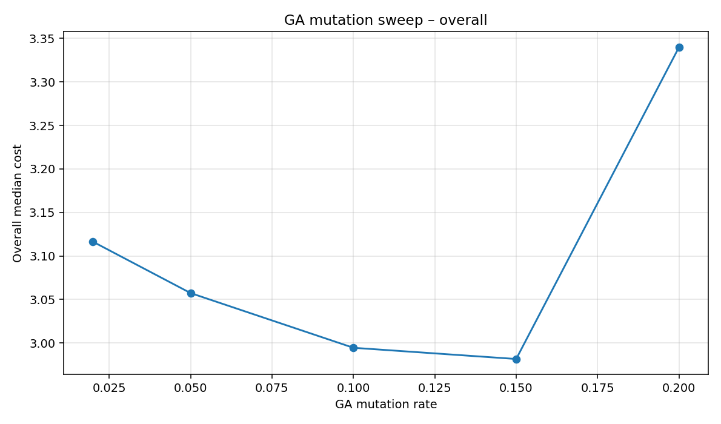
<Figure 3: Genetic Algorithm Mutation Rate Sweep >

Figure 4 shows the overall median tour cost from the genetic algorithm sweep over population sizes in the grid [10, 15, 20, 25, 30], with the mutation rate fixed to the best value from the previous stage and 50 generationsas specified in the code. Costs are highest at the smallest populaton of 10, then steadily decrease as the population grows, reaching the lowest overall median at 25. At 30 the cost rises again, indicating that very large populations dilute selection pressure and slow convergence within the fixed generation limit. This pattern fits the code’s setup: with relatively few generations, too small a population lacks diversity and converges prematurely, while too large a population spreads evaluations too thin. A mid-range size of 25 offers the best balance of diversity and convergence under the given parameters.
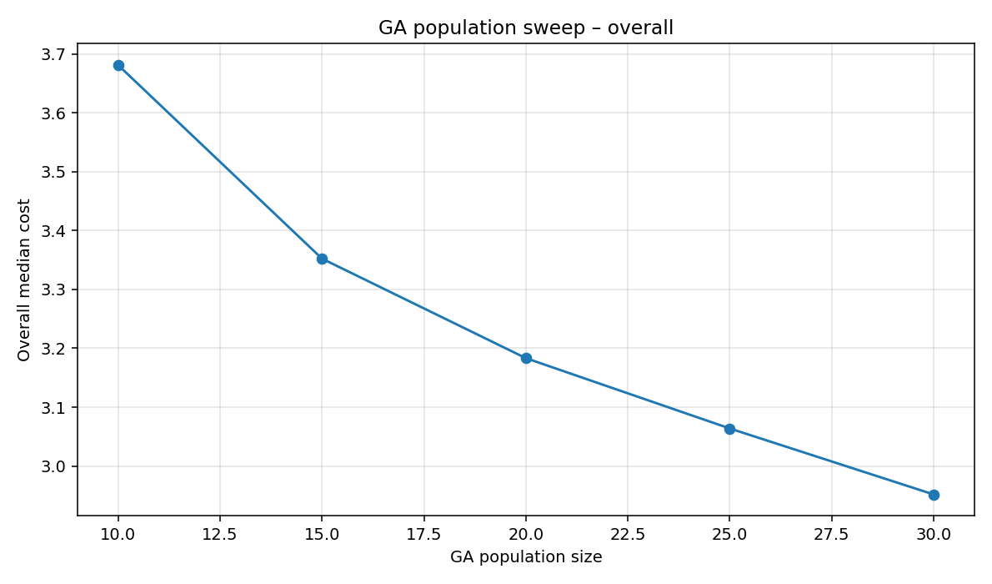
<Figure 4: Genetic Algorithm Population Size Sweep>

Figures 5~10 present the median best-so-far cost for hill climbing with 80 restarts across problem sizes from 5 to 30. For small instances the algorithm converges almost immediately, since the 2-swap neighborhood is limited and local optima are reached in only a few moves. As problem size increases, starting tours are worse and improvements take longer, so the curves decline more slowly and plateau later. This reflects the limits of first-improving search with early stopping and a fixed iteration cap. The main implication is that hill climbing yields fast gains on small problems but scales poorly, showing diminishing returns and weaker solution quality as $n$ grows.
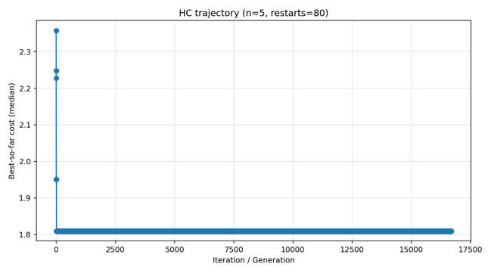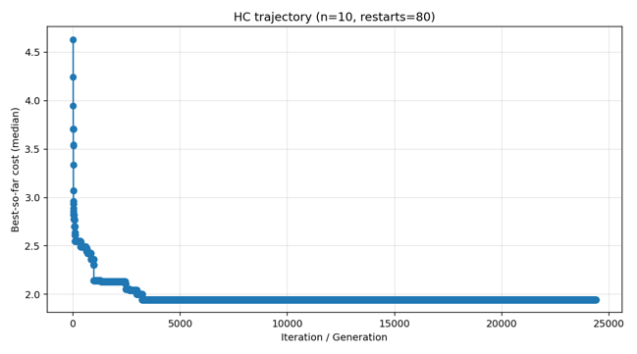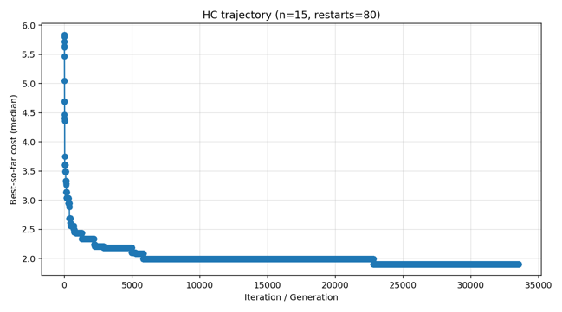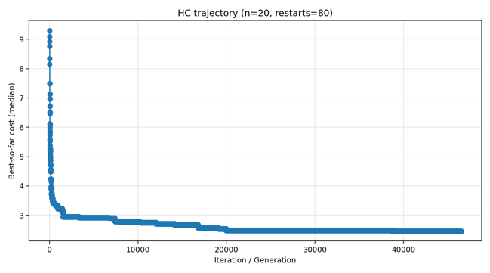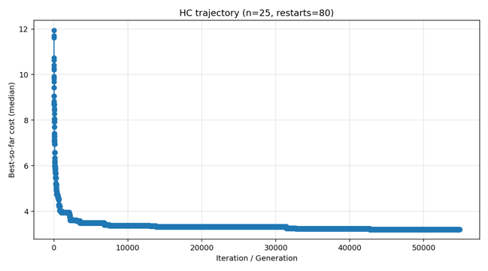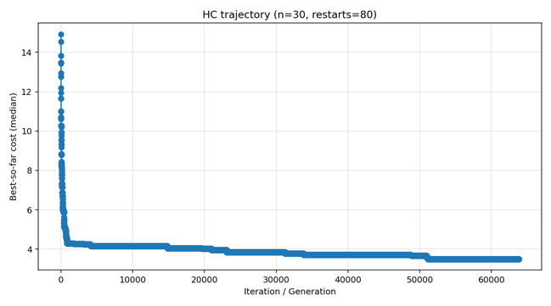
<Figure 5~10: Hil Climbing Trajectories>
Figures 11~16 track the median best-so-far cost for simulated annealing with $α= 0.995$, an initial temperature of 100, and 5000 iterations. For $n = 5$ the search finds the best tour almost instantly, and the curve flattens immediately. As the number of cities increases, the starting cost rises and the descent extends over more iterations, producing a stair-step pattern of gradual improvements. This behavior reflects the code’s geometric cooling: with $alpha = 0.995$ the temperature decays slowly to allow uphill moves early on, which helps escape shallow local minima, while later iterations consolidate improvements as the temperature drops. Larger instances show longer trajectories because more swaps are required to reduce high initial costs, but all runs eventually plateau once the iteration cap is reached. The implication is that SA scales better than plain hill climbing by maintaining exploration pressure, yet solution quality still depends heavily on the cooling schedule and iteration budget.

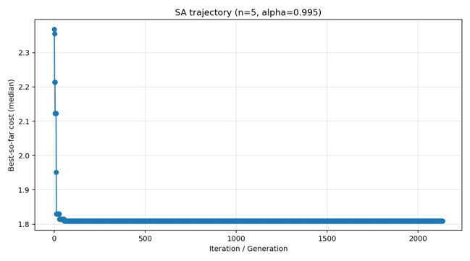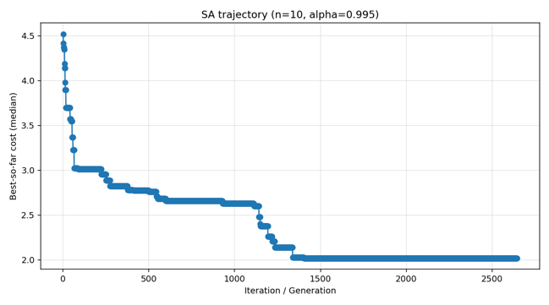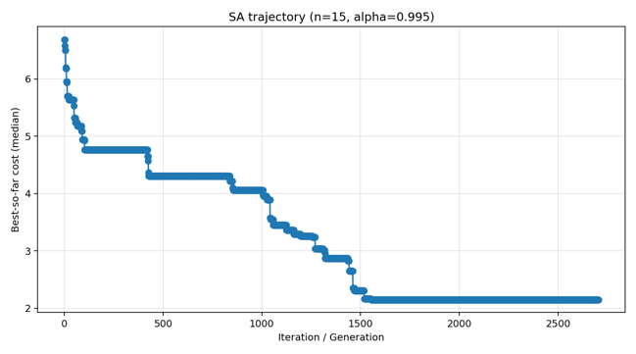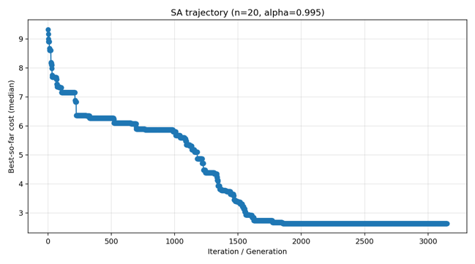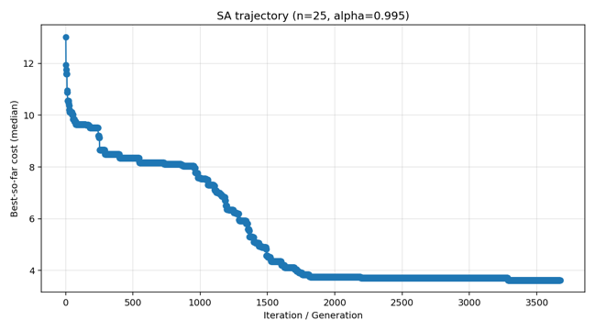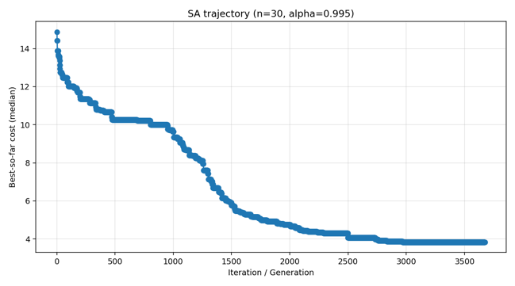
<Figure 11~16: Simulated Annealing Trajectories>
Figures 17~22 display a clear dependence on problem sizes. For $n = 5$, the best-so-far median cost remains flat across generations, indicating that the initial randomly generated population already contained near-optimal tours and that crossover and mutation operators provided no further improvement. This is because with a population size of 30 and a mutation rate of 0.15 the search space for five cities is so limited that good solutions are found immediately and converge without change. However, for $n = 10$ and larger, the trajectories show steep improvements in cost during early generations, followed by gradual refinements before leveling off. Overall, these results confirm that the GA implementation scales sensibly. Trivial cases converge instantly, while larger instances benefit from sustained evolutionary search before reaching near-optimal solutions.
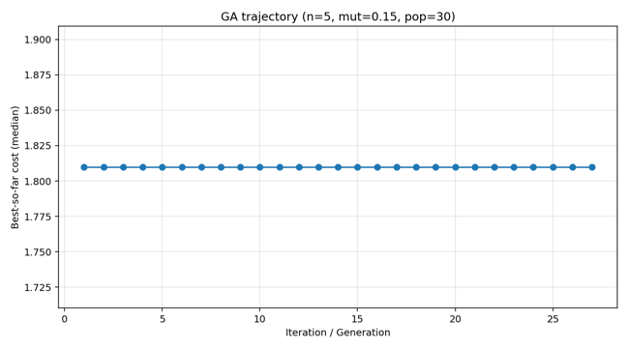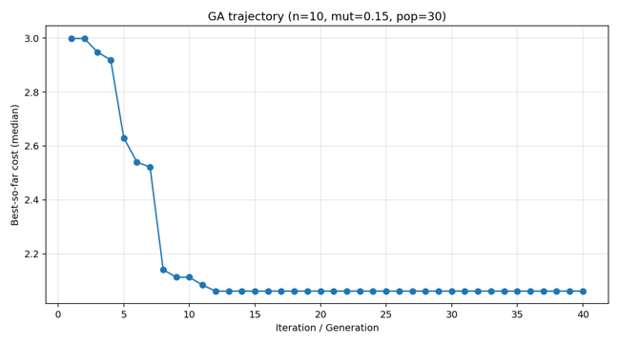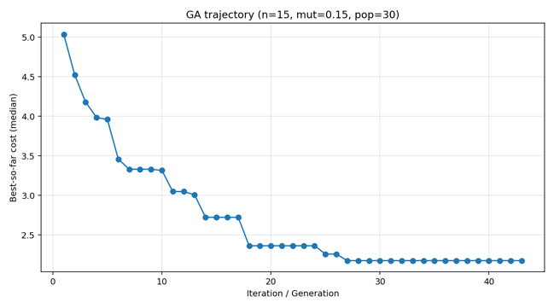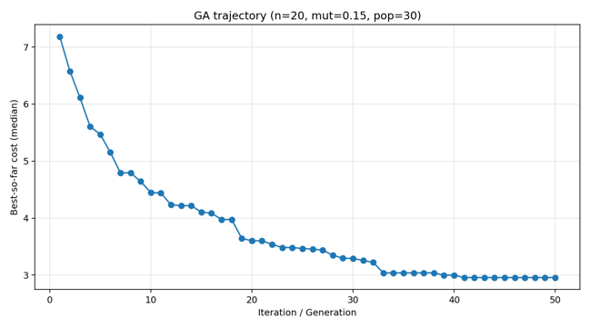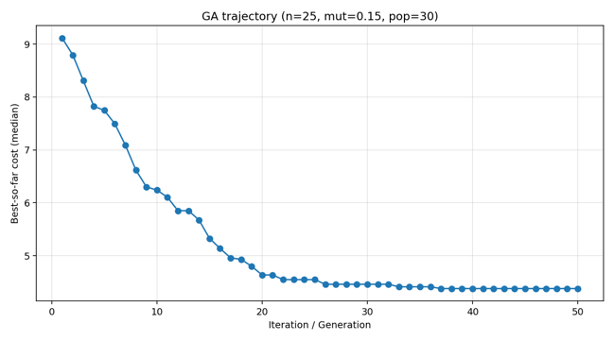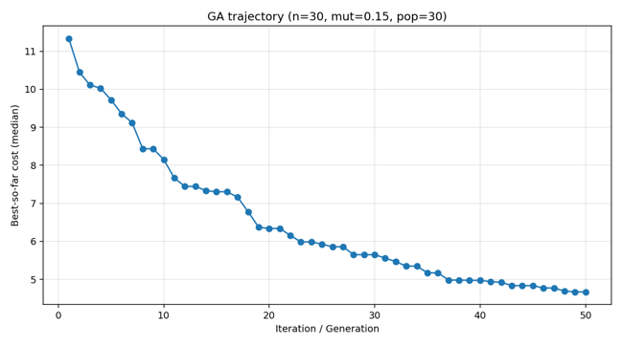
<Figure 17~22: Genetic Algorithms Trajectories>

Figures 23 through 25 highlight the trade-off between solution quality and scalability with four algorithms: A*, hill climbing, simulated annealing, and genetic algorithm. A* is both faster and more accurate for small instances. Hill climbing particularly shows large runtime overhead due to repeated restarts. As n increases, however, the rations invert: A* runtime grows exponentially and quickly becomes infeasible, while HC, SA, and GA remain polynomial and continue returning solutions. In particular, HC yields the lowest relative cost, SA offers a balance between speed and accuracy, and GA explores more broadly but at higher computational expense. These results confirm that while A* is optimal but practical for only small-sized problems, the stochastic algorithms become more attractive for larger instances.
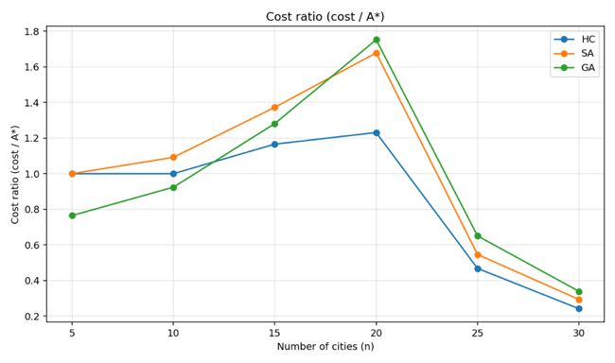
<Figure 23: Costs Based on A*>
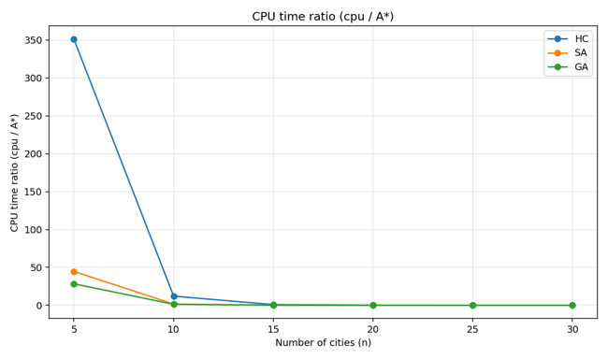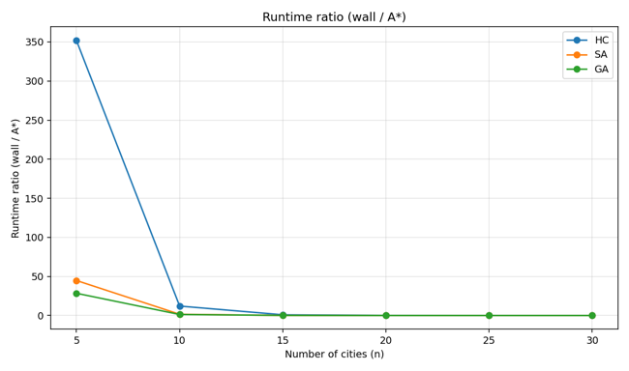
<Figure 24: CPU Times Based on A*>, <Figure 25: Wall Times Based on A*>

- Questions to Consider
- How are solutions to the traveling salesman problems represented by these algorithms? What does it mean to be a neighbor to one of these algorithm’s solutions?
  - In all algorithms the solutions take the form of the permutation of cities (travel_route). Neighbors are defined by swap_delta() function, which swaps the location of two cities. Thus, ‘neighbor’ refers to two solutions whose cities have been swapped.
- What hyperparameters were the best for each algorithm? Discuss the tradeoffs between different values for at least one hyperparameter per algorithm.
  - Hyperparameter used for testing hill climbing algorithm’s performance is num_restarts. The best score was shown when num_restarts was 80, the largest value on the grid. On the other hand this will apparently cause the runtime to increase linearly. For simulated annealing, $α$, the cooling speed was used as hyperparameter. The best score was made when $α= 0.995$, which implies that the value of $α$ that is either too low or high would affect negatively to the performance. Although the highest value did not guarantee the best score, as the value of $α$ gets larger, the runtime also increases. Lastly, for genetic algorithm, two hyperparameters were tested: mutation rate and population size. Like the value of $α$, mutation rate also showed the best performance when its value was neither too high nor low, implying that too low mutation rate is not that helpful, and too high value would make it chaotic. At the same time, the size of the population showed the best performance when its value was the highest, which causes its runtime to explode.
- Compare the performance of these algorithms with the performance of the nearest neighbor algorithms. What makes these algorithms better or worse choices than other algorithms?
  - While greedy algorithms based on Nearest Neighbor has extremely fast runtime, hill climbing, simulated annealing, and genetic algorithms could achieve higher accuracy thanks to their increased number of operations. Still, they are bound to practical runtime limitation, which gives place to greedy algorithms when the size of a problem is big.
- How do these algorithms compare with A*? When might you want to use A* over one of these algorithms? When might you use these algorithms over A*?
  - Thanks to MST heuristic, A* guarantees the optimal solution to be found. Yet its runtime grows exponentially as the problem sizes increases, so I will use A* when the size of a problem is relatively small, and HC, SA, and GA will be used for practical scale problems.
- How do these algorithms harness randomness to improve on deterministic algorithms like nearest neighbor or A*?
  - Thanks to this stochastic nature, the algorithms not only escape from local optima, but also search solutions in a wider range.
- Discuss for different real-world applications of the traveling salesman problem. Which algorithm would you chose (from all of the algorithms discussed) for each scenario? Try to choose setups and scenarios where different elements (time, cost, etc) are more relevant
    - Logistics and Delivery: Due to its vast scale, A* will not be able to be used. On the other hand, greedy algorithms are also likely to return solutions that are not good enough to use in terms of its cost. I will choose GA, as it provides me robust and diverse search in a solution set.
    - Tourist Itinerary Recommendations: In this case, the speed of returning an answer is highly important than its optimality, I will use nn+2opt, as it is so agile and the quality of a solution is reasonably good.
    - Designing the Ultimate House Choir Plan: Considering the scale of the problem is relatively small, I can use A* algorithm here, not to mention it guarantees the optimal solution so that I can finish all the chores in the best way it can be done.
    - Assembly line Optimization in a Factory: This problem is step-structured, and considering the total cost in manufacturing is highly important, I will use A*, not only because it guarantees the optimal solution that saves cost significantly but also the steps to consider are not that much.

